**Assignment 7.1:**

**Problem Statement:**

Calculate the number of employees corresponding to each skill from the table 'employee' which is loaded in the Demo.

**Steps:**

## Create databse named Demo:

hive> create database Demo;

## Create table named Employee:

hive> CREATE TABLE Employee

> (

> name STRING,

> skill STRING,

> rating INT,

> location STRING

> )

> ROW FORMAT DELIMITED

> FIELDS TERMINATED BY ',';

## Load data to the newly created ‘Employee’ table:

hive> LOAD DATA LOCAL INPATH '/home/acadgild/hive/emp_details.txt'

> INTO TABLE demo.Employee;

hive> select * from demo.Employee;

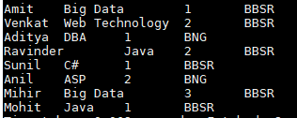

## Use below query to find number of employees corresponding to each skill.

hive> SELECT skill,COUNT(*) FROM demo.Employee GROUP BY skill;

